**How to deploy a create react app to Github pages**

### 1. Add homepage

Open your package.json file present inside your react app and add homepage property.

"homepage":"https://yourusername.github.io/repository-name"

replace the above url with your github username and repository name.

### 2. Install gh-pages

Next, we need to install a package called gh-pages.

npm install --save gh-pages

### 3. Deploy script

It’s time to add a deploy script commands in our package.json file.

"scripts":{

"predeploy": "npm run build",

"deploy": "gh-pages -d build",

}

Now in your terminal run npm run deploy

### 4. Setup source to gh-pages branch.

Once you successfully deployed open your GitHub code repository and click on settings tab if you scroll down you can see a GitHub Pages then choose a branch to gh-pages.

[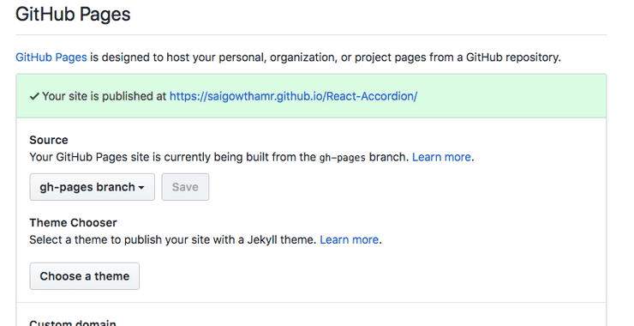](https://reactgo.com/static/f1b680b3a2d43d59ea55047e89a39948/817ae/react-ghpages-setup.png)

That’s it now you can see your react app URL like in the above image.